MySpeakingScore Widget —
Local Installation & Testing Guide
Version: 1.0 — Internal Evaluation Edition
Date: October 29 2025

✅ Overview
This package allows internal testers to run the MSS Speaking Widget Suite locally:
Component | Purpose
index.html | Main Menu — launch everything from here
WidgetAdmin.html | Manage branding, labels, API + logging settings
WidgetSurvey.html | View and edit survey questions
Widget.html | Full interactive scoring widget
dashboard.html | Visual score display & transcript
logger | Records log CSV of every submission
qa | Records QA activity and test results
✅ All core features run locally
🌐 Internet only required for scoring API calls
🍎 Supports Mac & Windows

📁 Folder Structure
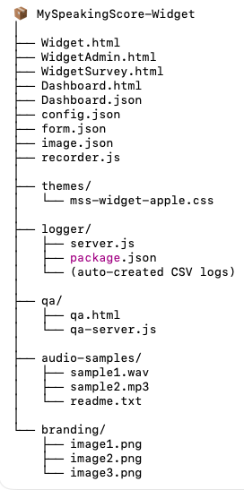
Note: the original folder structure was
../desktop/testform
You can use any folder as long as it contains the files and agrees with how you launch your local host.

🚀 Step-by-Step Installation
You must run 2 local services (and 1 optional one)— each in its own terminal window.
(or if you have a web service set up, just use that)

✅ 1️ Main Local Web Server (Port 8000)
Hosts: index, Widget, Admin, Survey, Dashboard
Mac Terminal
cd ~/Desktop/MySpeakingScore-Widget
python3 -m http.server 8000
Windows PowerShell
cd $HOME\Desktop\MySpeakingScore-Widget
py -m http.server 8000
Open browser:
➡ http://localhost:8000/index.html
✅ You should see the Main Menu

✅ 2️ Logging Server (Port 3010)
Records every scoring result to CSV
Mac:
cd ~/Desktop/MySpeakingScore-Widget/logger
node server.js
Windows:
cd $HOME\Desktop\MySpeakingScore-Widget\logger
node server.js
Expected output:
✅ Logger running on http://localhost:3010/log
CSV created daily:
logger/mss-log-YYYY-MM-DD.csv

✅ 3️ QA Logging Server (Port 3020) — Optional
Only needed when filling QA checklist (qa.html – provides some test cases and a way to log errors. You can skip this and do it later.)
Mac:
cd ~/Desktop/MySpeakingScore-Widget/qa
node qa-server.js
Windows:
cd $HOME\Desktop\MySpeakingScore-Widget\qa
node qa-server.js
Expected:
✅ QA Logger running on http://localhost:3020/qa-log

⚙️ Configuration in WidgetAdmin
Manage via:
➡ http://localhost:8000/WidgetAdmin.html
Section | Editable items
Widget Labels | Headline, button text, prompts
Theme | Apple design currently enabled
Branding | Upload or clear logo
API + Logging + Audio | API key, base URL, audio min/max, enable logger
✅ Save writes to:
- config.json
- form.json
- image.json

✅ Preview instantly updates the Widget (but you need to Save to update the underlying config and form json files)

🎤 Testing the Widget
Launch anytime:
➡ http://localhost:8000/Widget.html
Try both:
Test type | How
Record | Allow microphone → speak → Stop → Submit
Upload | Use files in /audio-samples/
After scoring:
✅ Dashboard appears
✅ Debug JSON available
✅ Log entry created

📊 CSV Logging Validation
Open:
logger/mss-log-YYYY-MM-DD.csv
Each row should include:
Column
timestamp
ip
fileName
lengthSec
submitTime
toefl / ielts / pte / cefr
question
transcript
wpm
If missing values → report during testing ✅

📱 Optional: Testing from Your Phone (skip this for now)
Must be on same Wi-Fi
Find computer IP:
Mac:
ifconfig | grep inet
Windows:
ipconfig
Then:
➡ http://YOUR-IP:8000/Widget.html
✅ Allow microphone access
✅ Score submission works the same

✅ QA Test Plan (or just manually test)
Note – we will flush this out later for qa testers
Test checklist:
➡ http://localhost:8000/qa/qa.html
Results auto-save to:
qa/qa-log-YYYY-MM-DD.csv
✅ Complete all checks
✅ Report issues to the team

🧯 Troubleshooting
Issue | Solution
“Submit failed (400)” | Check audio duration + supported format
CSV not updating | Ensure logger server (3010) is running
Microphone blocked | Enable in browser privacy settings
Labels missing | Confirm editable:true in config
Dashboard not showing | Refresh widget + re-submit

✅ Completion Checklist
Item | Verify
Main menu loads | ☐
Recording + playback works | ☐
Upload works | ☐
Submit → CEFR dashboard shows | ☐
JSON visible in Debug | ☐
Logger CSV contains results | ☐
QA suite completed | ☐

